Orientation Selectivity in the Primary Visual Cortex of the mouse

## Variraptor Geommu

Teacher Assistant: Hadi Choubdar Project Assistant: Mohammed Rabiei

Project Mentor: Margarita Zachariou

Project Member:

1. Fatema Darweesh
2. Rahma Abbas
3. Mohammed Albyoumi
4. Shivam Jaiswel
5. Aditya Agrawal
6. Argha
7. Vinayak



The primary visual cortex (V1) is crucial for visual perception, playing a causal role in the recognition, categorization, and awareness of visual stimuli. Studies have shown that V1 neurons respond to stimuli through feedforward input from the retina. Recent research suggests that movement improves neural storage of visual cues in V1. However, there is still disagreement on whether V1 blood oxygenation level-dependent signals are generated, supporting the theory that V1 activity does not correspond with visual perception (Jiao et al., 2022).

Mouse V1 has multiple layers, each interpreting visual information differently, demonstrating animal species similarities (Kirchberger et al., 2023).

1. Layer one (L1) neurons are inhibitory, receiving input from the thalamus and cortical regions, integrating brain data, and modulating sensory inputs.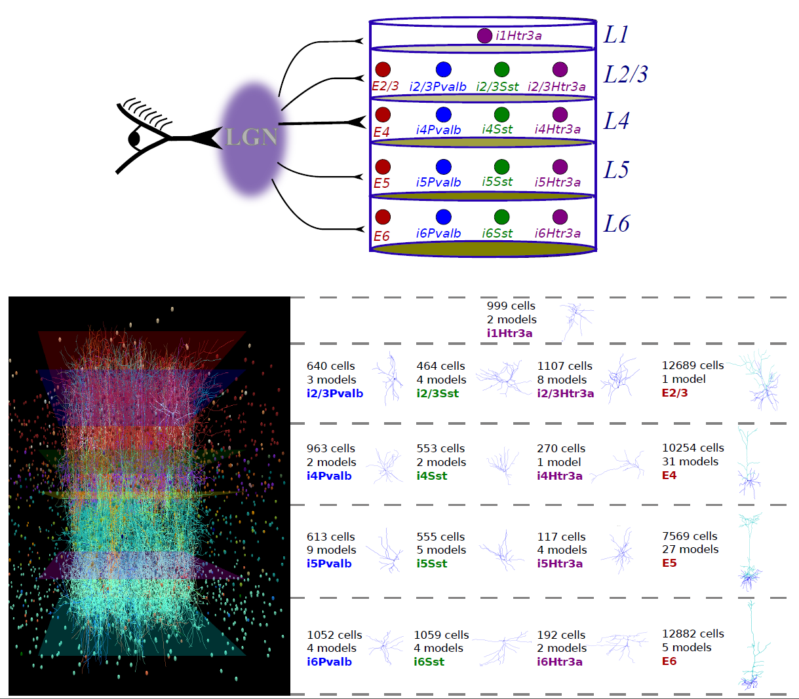
2. Layer 2/3 processes visual information, receiving input from the thalamus. Its circuits, formed by excitatory and inhibitory neurons, integrate data from various properties, including direction and spatial frequency.
3. Layer 4 processes visual properties, receives input from the thalamus, and projects excitatory neurons to other layers.
4. Layer 5 (L5) consists of excitatory and inhibitory neurons, integrating visual data from V1's layers, including the superior colliculus and thalamus.
5. Inhibitory neurons in layer 6 modulate sensory inputs and control information flow between V1 and other brain regions.

Orientation selectivity is a fundamental property of neurons in the primary visual cortex of many mammals including rodents. Studies have shown that, in cats, neurons with different orientation preferences have been organised in iso-orientation domains that are smooth and

contentious at the cellular scale (Kaschube et al., 2014). However, in rodents, findings have shown that such organisation does not exist, rather, the neurons with different orientation preferences are like “salt and pepper” in V1 (Fahey et al., 2019, Kondo et al., 2016, Kaschube et al., 2014). On the other hand, other studies argue that the structure of the orientation map in rodents can be understood via the smallest anatomical module in the cortical architecture which is the minicolumn (Kondo et al., 2016). Accordingly, further research is needed to fully understand the mechanisms underlying the orientation selectivity structure in rodents.

Therefore, in our project, we will investigate the response of a huge population of neurons in the primary visual cortex of a mouse to orientation stimuli. The stimulus shown to the head-fixed mouse is a static grating that rotates at random angles each trial. The data was recorded using 2-Photon Calcium imaging which allows for the capture of 20,000+ neurons. Using this data, we are aiming to identify and characterise neurons that exhibit orientation selectivity, i.e., they preferentially respond to specific orientations of visual features, in our case gratings. To do so, after performing data preprocessing, we will apply different statistical analyses on the data such as Orientation Selectivity Index (OSI), ANOVA, and visualisation analysis. Additionally, by studying such results we seek to unravel the neural architecture that underlies the processing of the orientation feature.

It is worth mentioning that the data we are using has not been used to study orientation selectivity before. Also, the studies mentioned earlier used different stimuli and approaches to investigate this principle.

**References:**

Montijn, J. S., Goltstein, P. M., & Pennartz, C. M. (2015). Mouse V1 population correlates of visual detection rely on heterogeneity within neuronal response patterns. *ELife*, *4*, e10163. <https://doi.org/10.7554/eLife.10163>

Kirchberger, L., Mukherjee, S., Self, M. W., & Roelfsema, P. R. (2023). *Contextual drive of neuronal responses in mouse V1 in the absence of feedforward input*. *9*(3). <https://doi.org/10.1126/sciadv.add2498>

Jiao, C., Li, M., & Hu, D. (2022). The neurons in mouse V1 show different degrees of spatial clustering. *Brain Research Bulletin*, *190*, 62–68. <https://doi.org/10.1016/j.brainresbull.2022.09.011>

Dadarlat, M. C., & Stryker, M. P. (2017). *Locomotion Enhances Neural Encoding of Visual Stimuli in Mouse V1*. *37*(14), 3764–3775. <https://doi.org/10.1523/jneurosci.2728-16.2017>

Kaschube, Matthias. “Neural Maps versus Salt-And-Pepper Organization in Visual Cortex.” *Current Opinion in Neurobiology*, vol. 24, no. 24, Feb. 2014, pp. 95–102, <https://doi.org/10.1016/j.conb.2013.08.017>.

Fahey, Paul, et al. *A Global Map of Orientation Tuning in Mouse Visual Cortex*. 23 Aug. 2019, <https://doi.org/10.1101/745323>.

Kondo, Satoru, et al. “Mixed Functional Microarchitectures for Orientation Selectivity in the Mouse Primary Visual Cortex.” *Nature Communications*, vol. 7, no. 1, 21 Oct. 2016, <https://doi.org/10.1038/ncomms13210>.

‌

‌

‌

The primary visual cortex (V1) is crucial for visual perception, playing a causal role in the recognition, categorization, and awareness of visual stimuli. Studies have shown that V1 neurons respond to stimuli through feedforward input from the retina. Recent research suggests that movement improves neural storage of visual cues in V1. However, there is still disagreement on whether V1 blood oxygenation level-dependent signals are generated, supporting the theory that V1 activity does not correspond with visual perception (Jiao et al., 2022).

Orientation selectivity is a fundamental property of neurons in the primary visual cortex of many mammals including rodents. Studies have shown that, in cats, neurons with different orientation preferences have been organised in iso-orientation domains that are smooth and contentious at the cellular scale (Kaschube et al., 2014). However, in rodents, findings have shown that such organisation does not exist, rather, the neurons with different orientation preferences are like “salt and pepper” in V1 (Fahey et al., 2019, Kondo et al., 2016, Kaschube et al., 2014). On the other hand, other studies argue that the structure of the orientation map in rodents can be understood via the smallest anatomical module in the cortical architecture which is the minicolumn (Kondo et al., 2016). Accordingly, further research is needed to fully understand the mechanisms underlying the orientation selectivity structure in rodents.

Therefore, in our project, we will investigate the response of a huge population of neurons in the primary visual cortex of a mouse to orientation stimuli. The stimulus shown to the head-fixed mouse is a static grating that rotates at random angles each trial. The data was recorded using 2-Photon Calcium imaging which allows for the capture of 20,000+ neurons. Using this data, we are aiming to identify and characterise neurons that exhibit orientation selectivity, i.e., they preferentially respond to specific orientations of visual features, in our case gratings. To do so, after performing data preprocessing, we will apply different statistical analyses on the data such as Orientation Selectivity Index (OSI), ANOVA, and visualisation analysis. Additionally, by studying such results we seek to unravel the neural architecture that underlies the processing of the orientation feature.

It is worth mentioning that the data we are using has not been used to study orientation selectivity before. Also, the studies mentioned earlier used different stimuli and approaches to investigate this principle.